Contacts for BETA LAMBDA Chapter
Red Bluff, California
BetaLambdaDKG.weebly.com

President: Mary Craig – 527-3140 redbluffcraig@aol.com
Annette Null - 527-5794 DKGannette@gmail.com
Lee Shilts - 527-8357 sharonleeshilts@gmail.com

Area II includes Butte, Colusa, Glenn, Lassen, Modoc, Plumas, Shasta, Sierra, Siskiyou,
Sutter, Tehama, Trinity, and Yuba Counties.

AREA II Chapters
ALPHA NU, Chico
BETA ALPHA, Redding
BETA LAMBDA, Red Bluff
BETA OMEGA, Yuba City
GAMMA NU, Mt. Shasta
IOTA SIGMA, Marysville

Contact Area II Director, Ginny Z., at gzopolos@yahoo.com
for information about the other area chapters.

PURPOSES OF THE DELTA KAPPA GAMMA SOCIETY
1. To unite woman educators of the world in genuine spiritual fellowship;
2. To honor women who have given or who evidence a potential for distinctive service in any field of education;
3. To advance the professional interest and position of women in education;
4. To initiate, endorse and support desirable legislation or other suitable endeavors in the interest and education of women educators;
5. To endow scholarships to aid outstanding women educators in pursuing graduate study and to grant fellowships to women educators from other countries;
6. To stimulate the personal and professional growth of members and to encourage their participation in appropriate programs of action;
7. To inform the membership of current economic, social, political, and educational issues so that they may participate effectively in a world society.

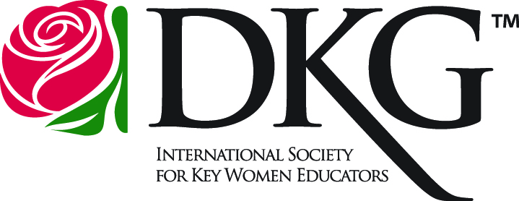
DELTA KAPPA GAMMA

Beta Lambda Chapter
Red Bluff, CA

A Society for Women Educators
who impact education worldwide.

DKG Mission:
The Delta Kappa Gamma Society International promotes professional and personal growth of women educators and excellence in education.

DKG Vision:
Leading women Educators Impacting Education Worldwide

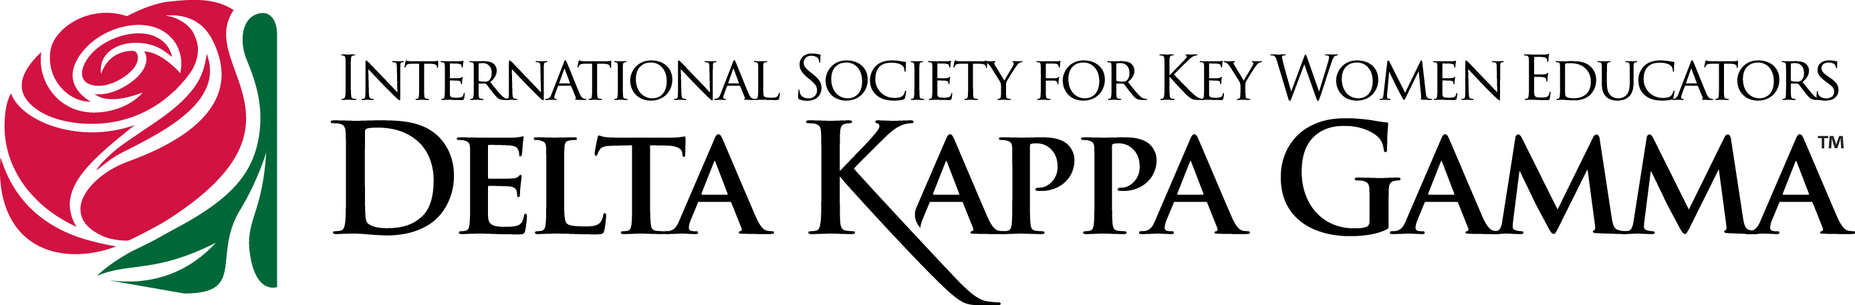
DKG - Beta Lambda Chapter
2017-2018 Program Schedule

September 12, 2017, Tuesday, 5:30, St. Peter’s Episcopal Church, Scholarship Dinner, Welcome Back Dinner and Recommitment Ceremony
October 14, 2017, Saturday, Area II Fall Luncheon in Mt. Shasta
October 19, 2017, Thursday, 5:30, TCDE,
Makerspace and STEAM Presentation
November 14, 2017, Tuesday, 5:30, Annette's Home,
Initiation and World Fellowship
December 9, Saturday, 8:30-11:30 a.m., TCDE, Brunch and Boutique
January 20 or 27, 2018, Saturday, Vina Monastery Field Trip
February 15, 2018, Thursday, 5:30, TCDE,
Educational Trends, Superintendent of Tehama Co. Schools
March 10, 2018, Saturday, Area II Spring Luncheon in Yuba City
March 20, 2018, Tuesday, RBHS, Technology: Google Docs
April 12, 2018, Thursday, 5:30, Foster Youth Aging Out Baskets, Schools for Africa, RBHS Student Presentation
May 12, 2018, Saturday, 9 a.m., St. Peter’s Episcopal Church, Scholarship Brunch and Installation of Officers
June 14, 2018, Thursday, 5:30, Location TBA, End of Year Potluck

If interested in attending a meeting, contact any member,
or Annette Null 527-5794, DKGannette@gmail.com

Beta Lambda Chapter
WHO: Beta Lambda is the local chapter of the Delta Kappa Gamma Society International which promotes personal and professional growth of women educators and excellence in education.

WHAT: The Society has seven general purposes that members strive to achieve annually; these purposes are incorporated in our local goals and projects.

WHEN: The International Society was established in 1929; Beta Lambda was organized in 1950.

WHERE: The Beta Lambda chapter incorporates Glenn and Tehama counties.

WHY: Beta Lambda members are dedicated professionals devoted to enhancing education and fostering literacy. Our professional growth is on-going, and we wish to share this with the community.

HOW: Our local projects, at the present time, include:

Children’s Fair—purchasing books to distribute at the annual Children’s Fair and other events, in partnership with Tehama County Reading Council.

Scholarships and Grants—offering financial aid to deserving female high school and college students pursuing a career in education.

Support for Aging-out Foster Youth—useful items in “Getting Started Baskets” and “Personals Kits” distributed through Foster and Homeless Youth Services of the Tehama County Department of Education.

